

**Applied Project (CSAT-CSAC)**

**Researcher Management**

**Instructor: William Pourmajidi**

**Group: CPL-5559-CSAT-CSAC-0098-V2**

**Date:02/July/2020**

**Student Name: Student ID:**

**Jasveer Kaur Cheema C0726681**

**Parampreet Kaur C0744528**

**Sukhdeep Singh C0754215**

**Sonia Dhunna C0738121**

**INDEX**

**1. Introduction**

**Screenshot of page 1.1**

**Screenshot of database 1.2**

**Screenshot of GitHub 1.3**

**Reference 1.4**

**1.1 Screenshot of pages: -**

**1.2 User Page: -**

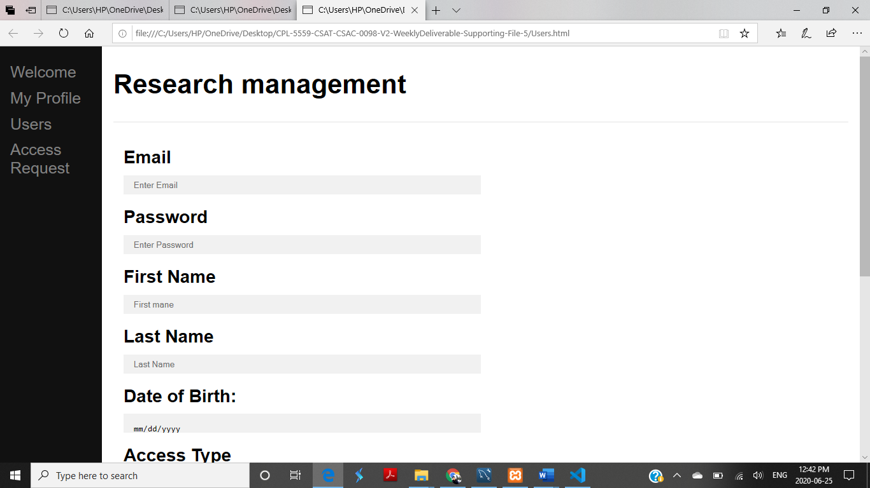

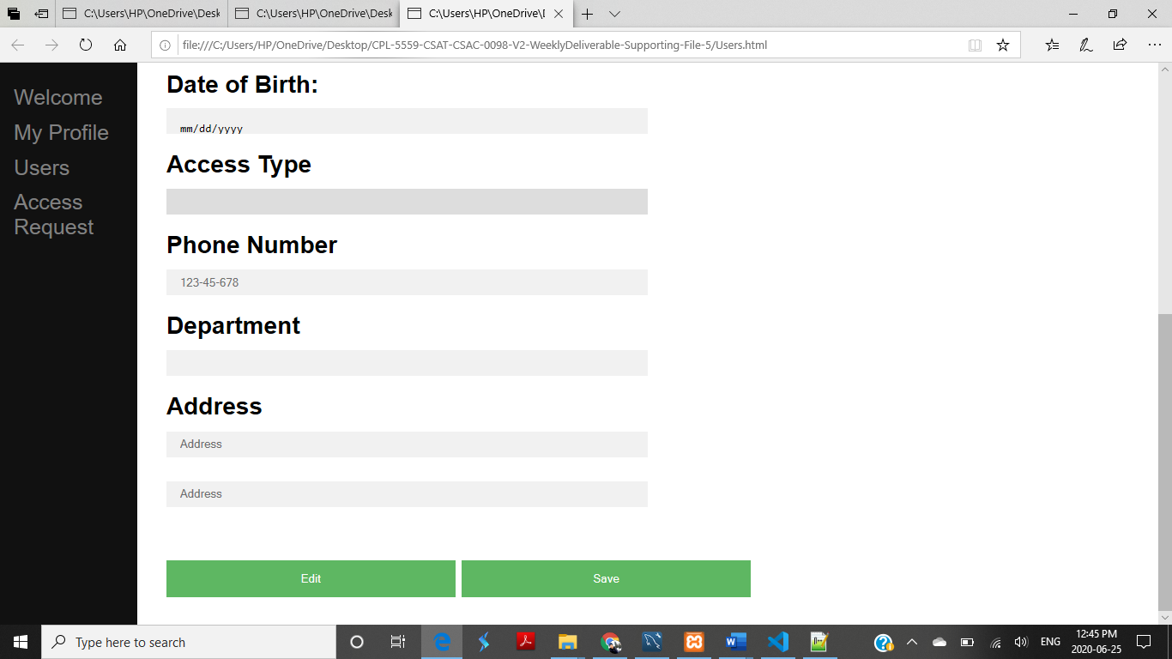

**User Page: -**

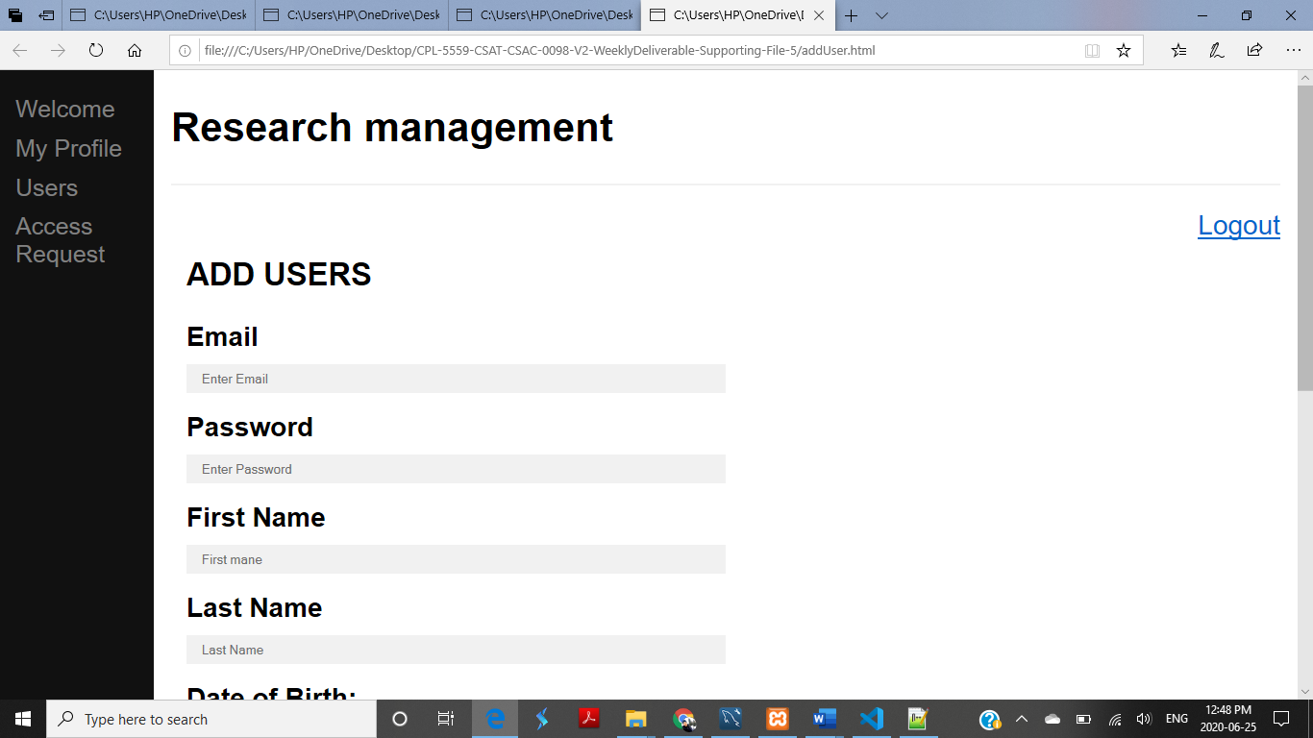

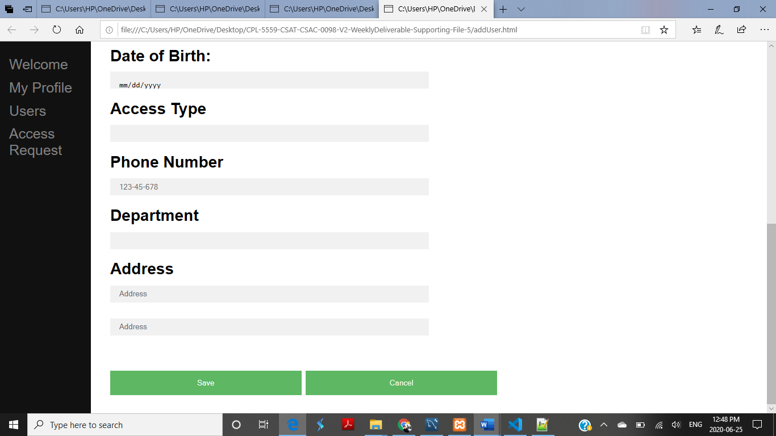

**Regular user: -**

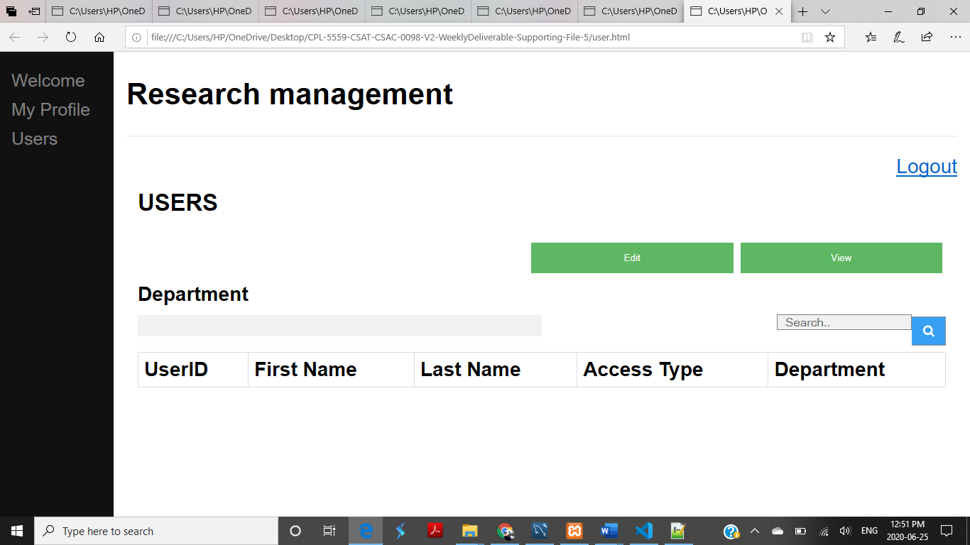

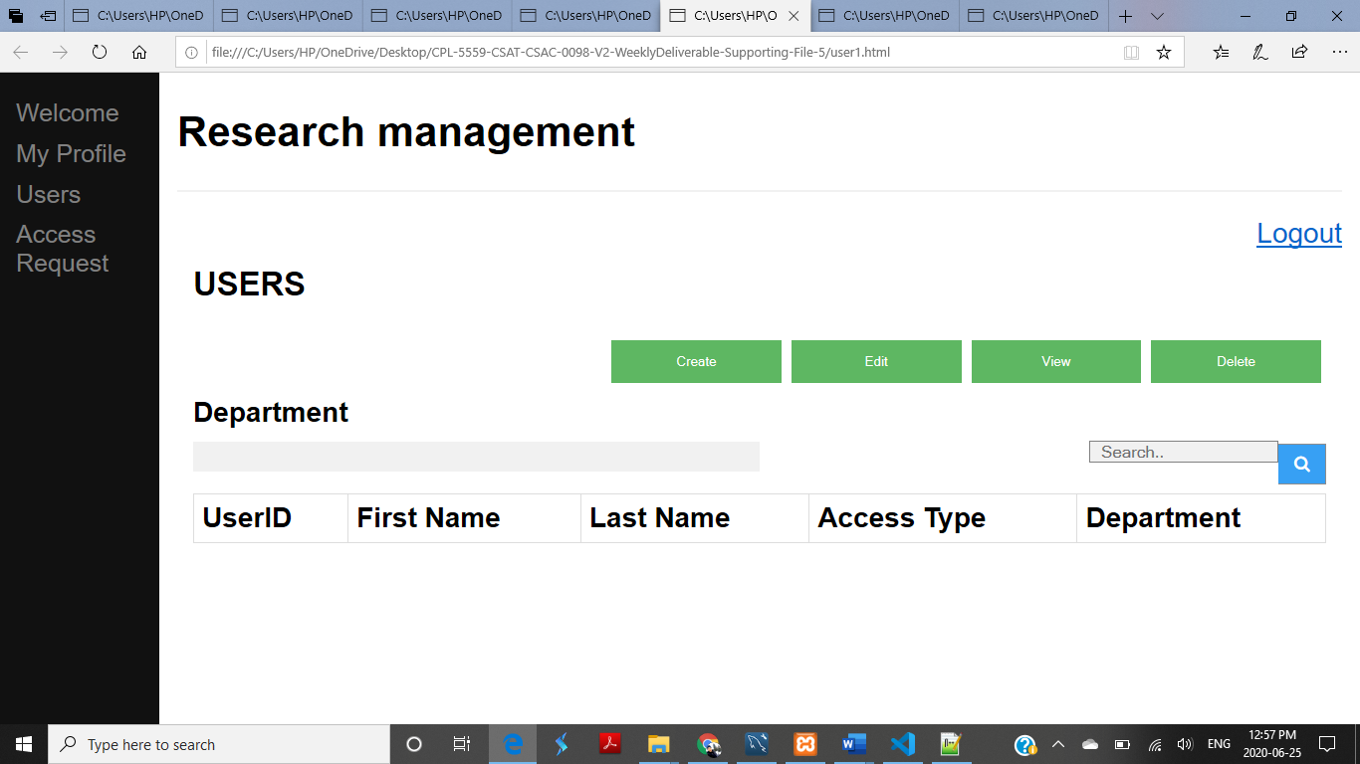

**Administror:-**

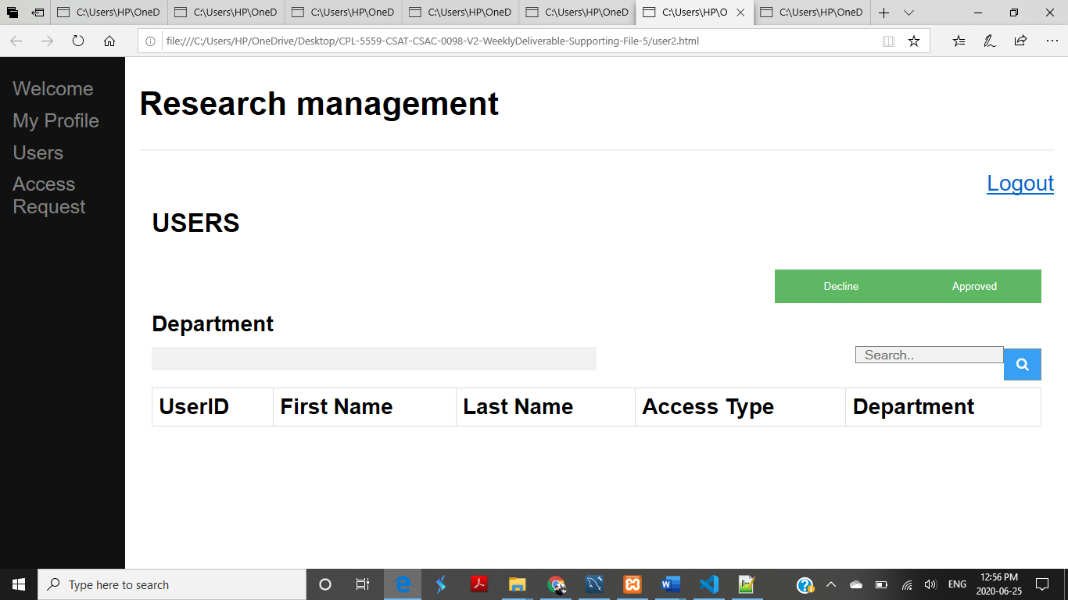

**1.2 Screenshots of database: -**

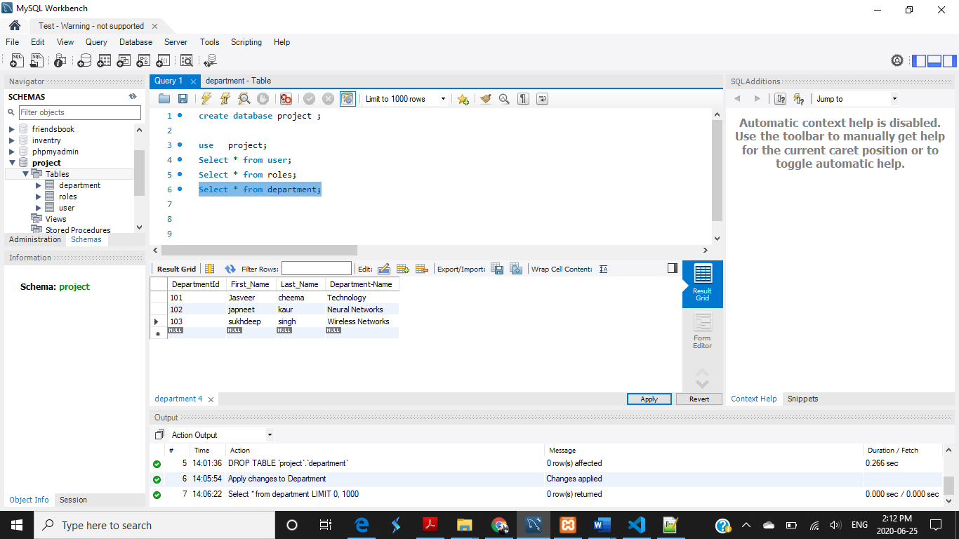

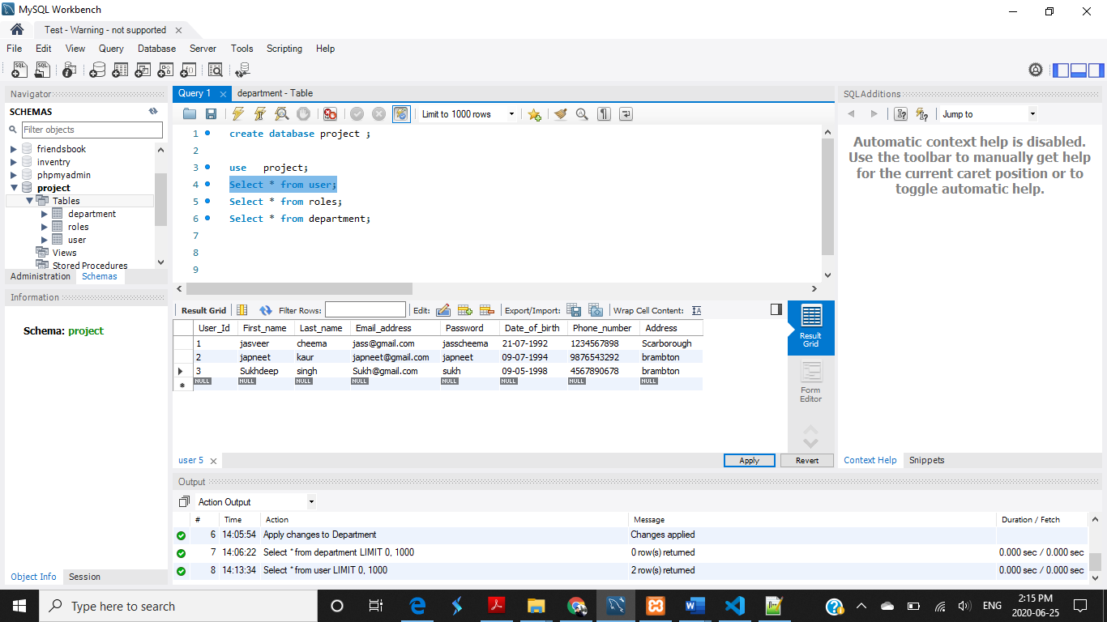

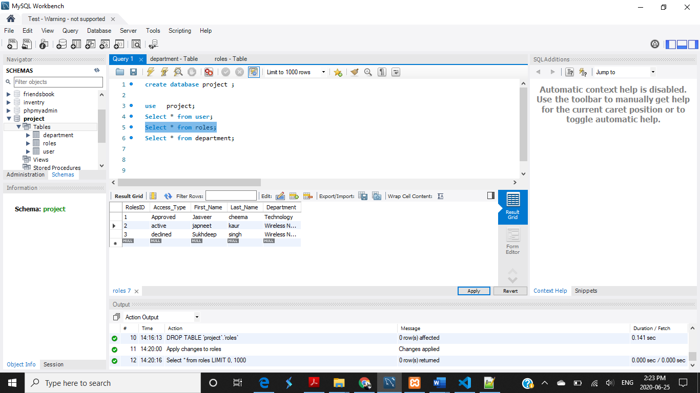

**1.3 Screenshot of GitHub: -**

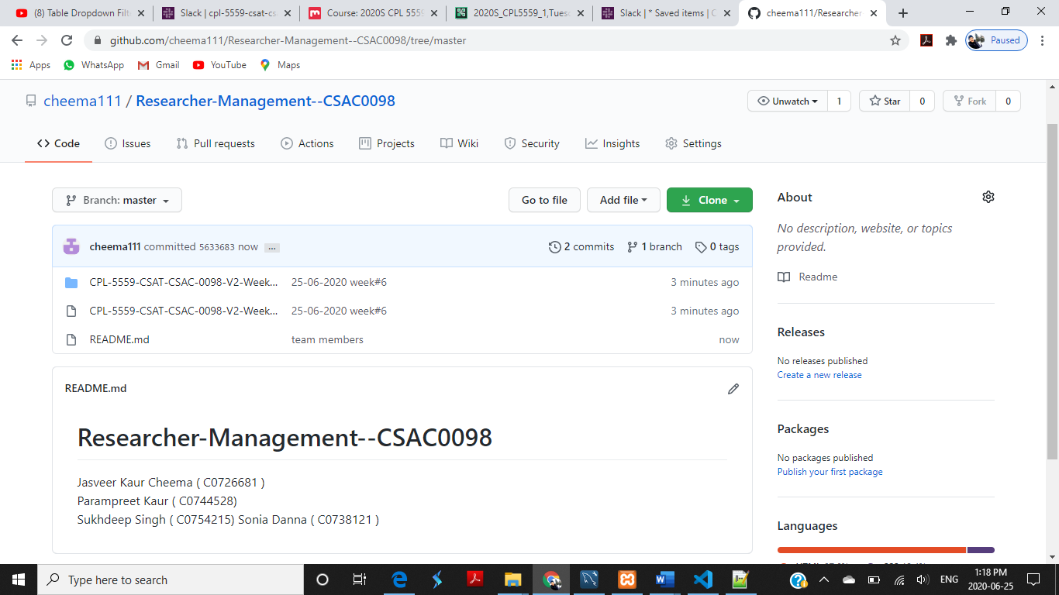

**1.3 Reference: -**

<https://www.youtube.com/watch?v=gzZ-bb11Q_s>

<https://www.youtube.com/watch?v=gxuabrSwcXU&feature=youtu.be>

**WEEK 7**

**INDEX**

**1. Introduction**

**Screenshot of pages 1.1**

**Screenshot of database 1.2**

**Reference 1.3**

**Following are the screenshots of Pages:**

**1.1 Screenshots of validations and function that used on signup page**

* **Signup page:**

This is a Screenshot of signup page with validations. Users' needs follow these. If user enter data which is not validate then these error messages will show on the page.

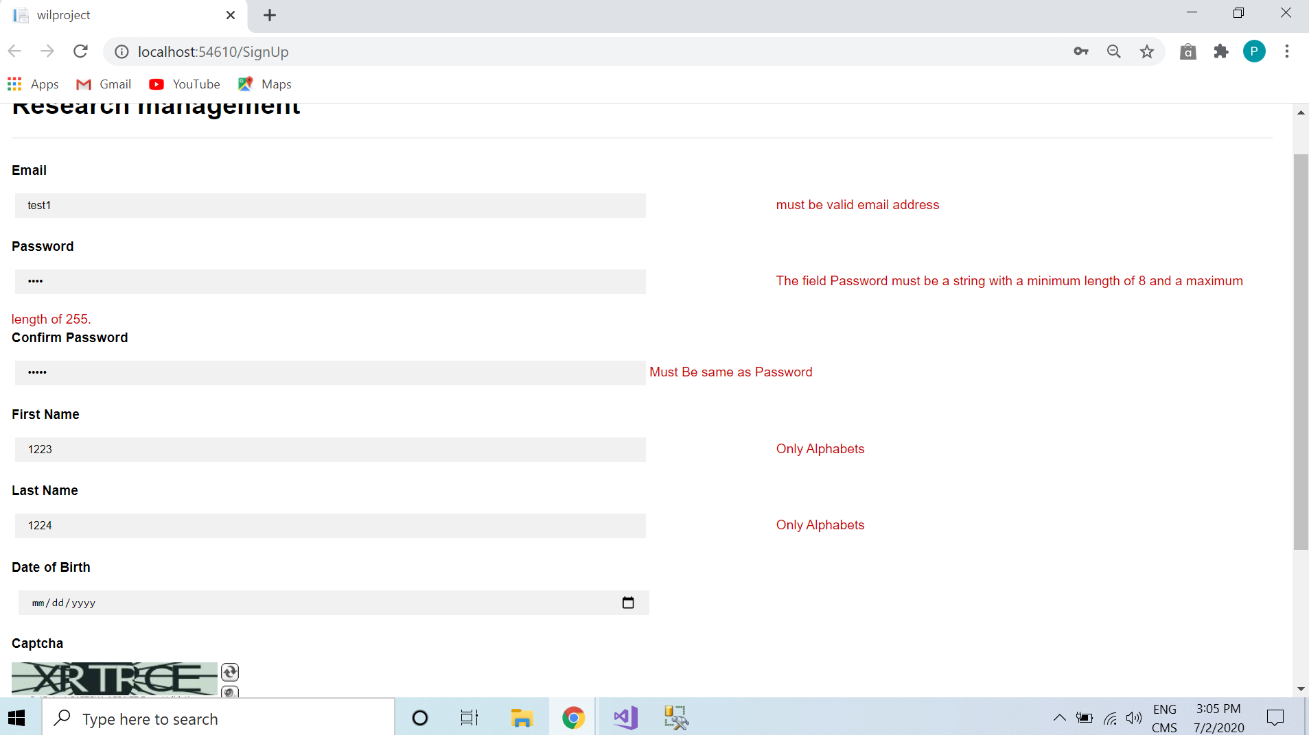

* **Captcha verification and Date picker validation:**

It allows the users to select date from date picker and signup function controlled by the captcha.

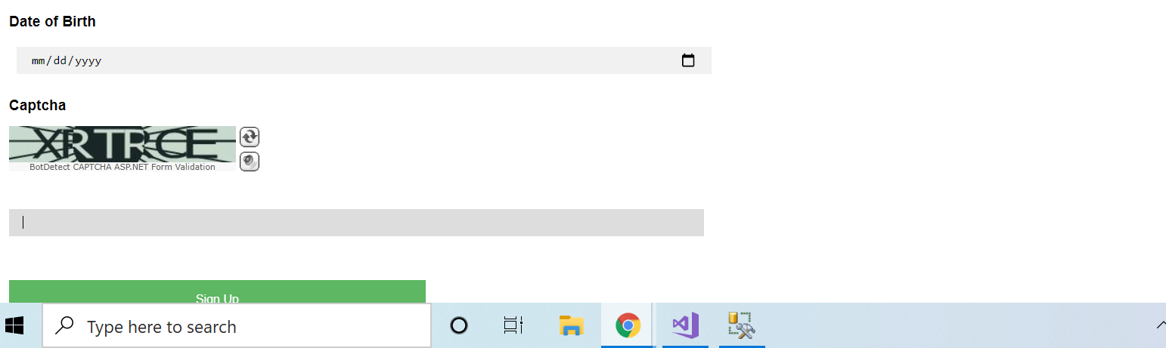

* **Sign up:**

Signup needs for the new users.

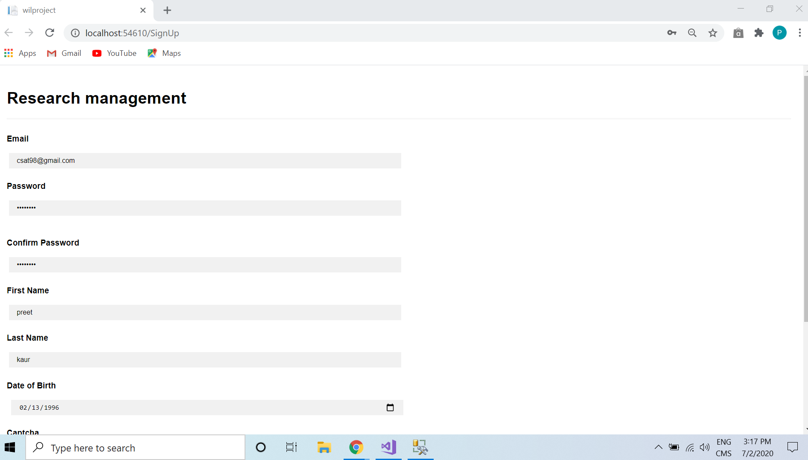

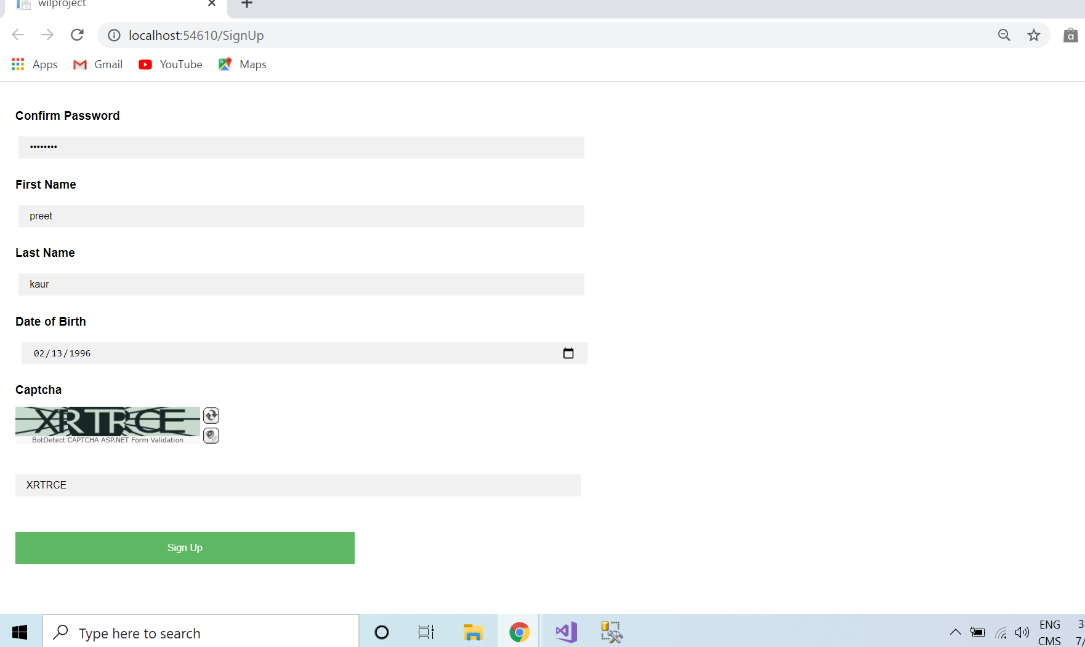

* **Login page:**

In login page users need to enter their user’s name as email address that they used at the time of signup as well as same password.

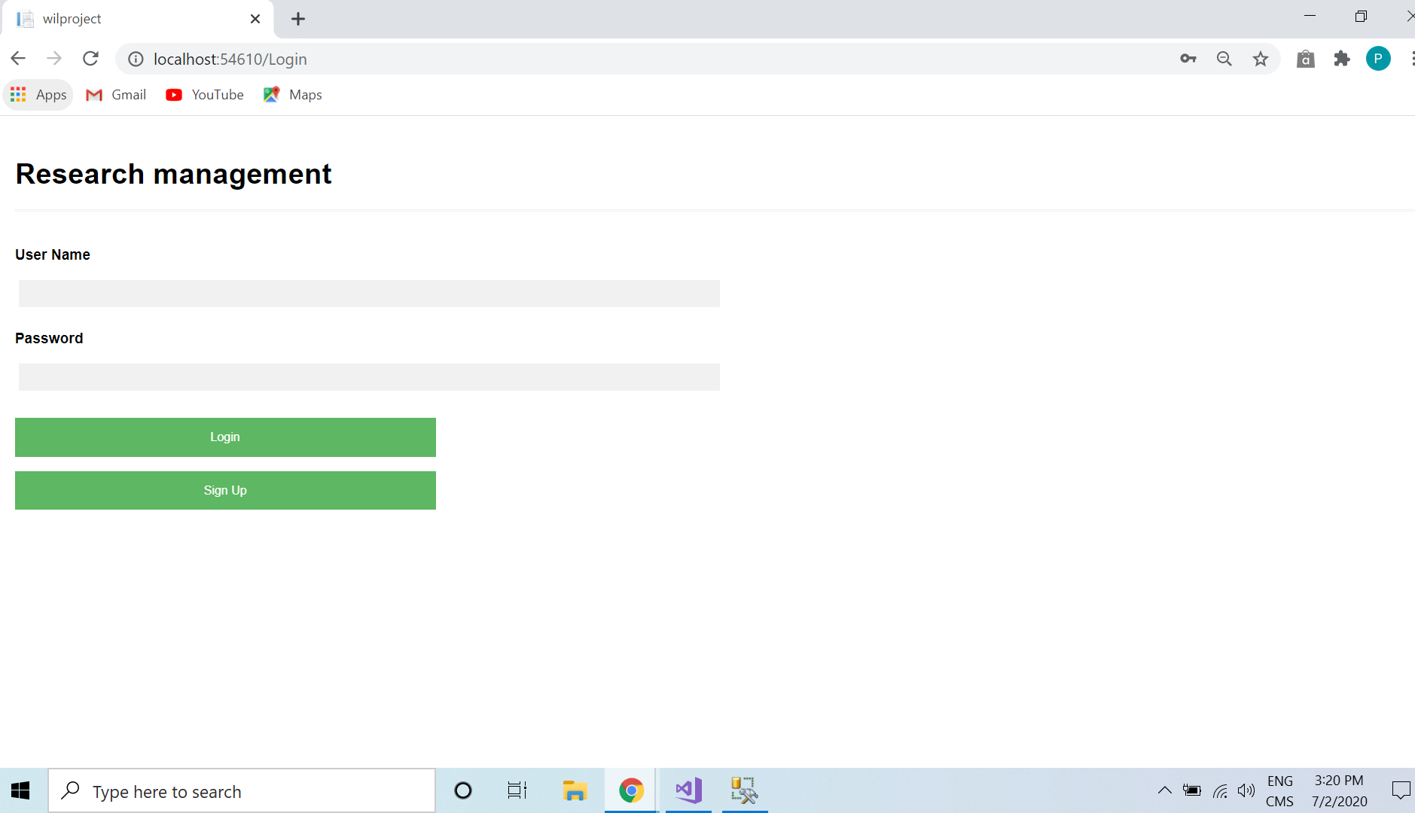

* **Username validation:**

If user enter wrong information following message will show on the page.

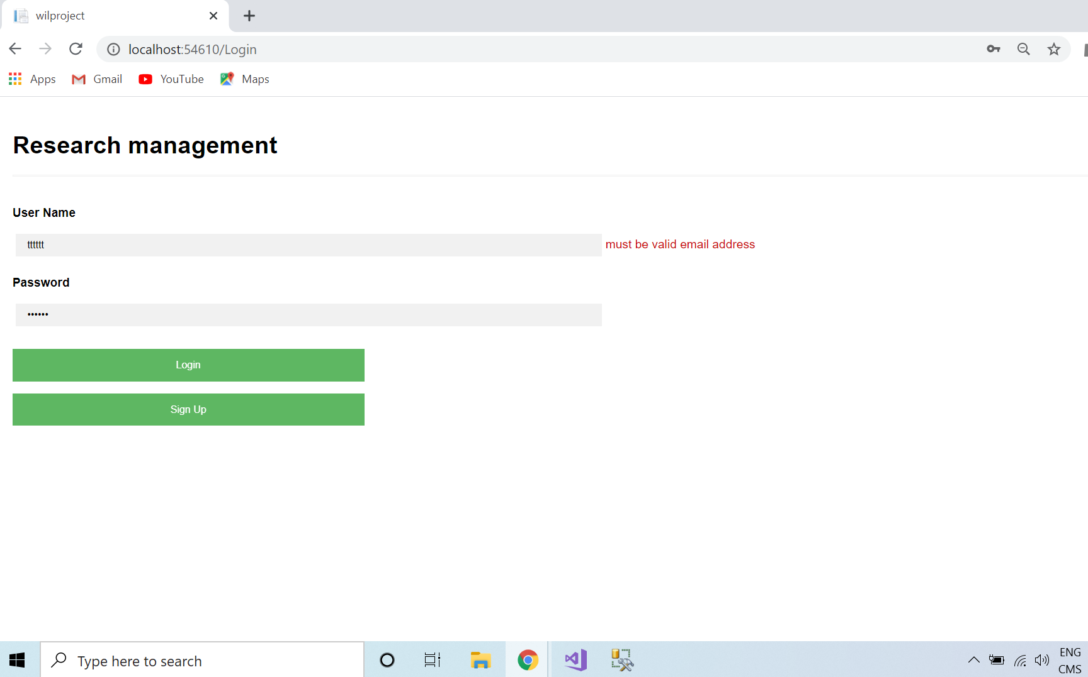

* **Username and password must match for the login:**

Login is possible only if users enter correct data.

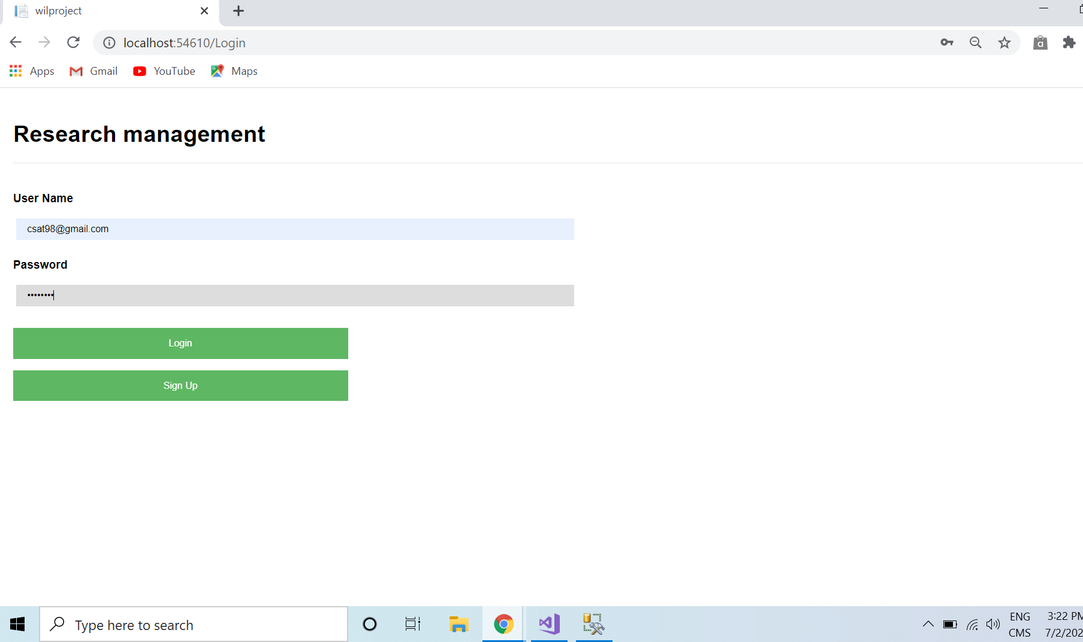

* **Login function and Welcome page Function:**

After entering the correct username and password click on login user land on the appropriate page in which they are validated and according to their access type.

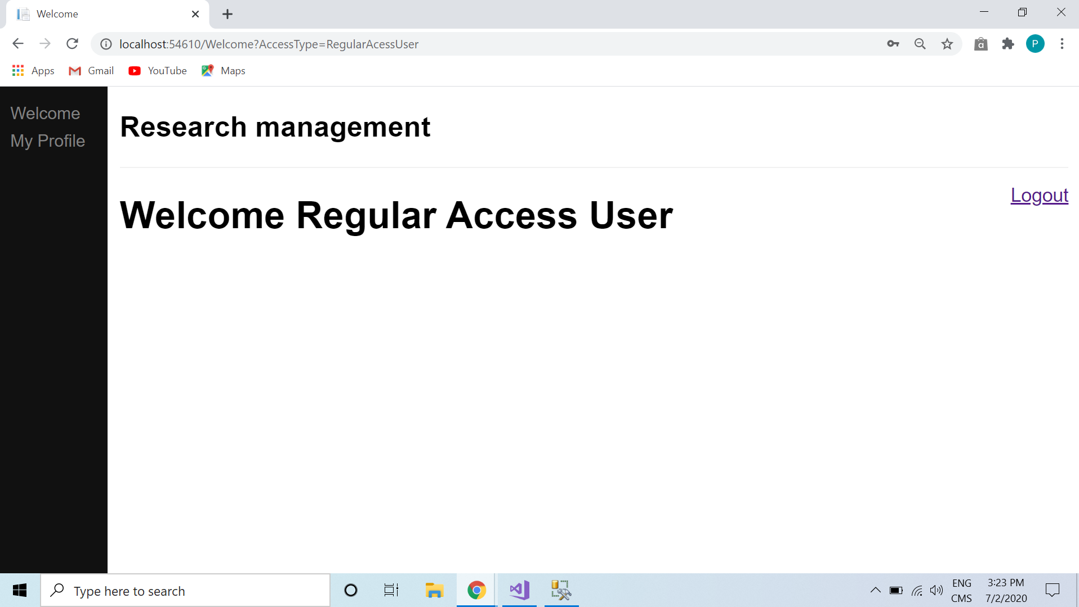

* **Admin's login and welcome page:**

Welcome pages look according to the user's access type. User will see only those things on the welcome page which they can access and use.

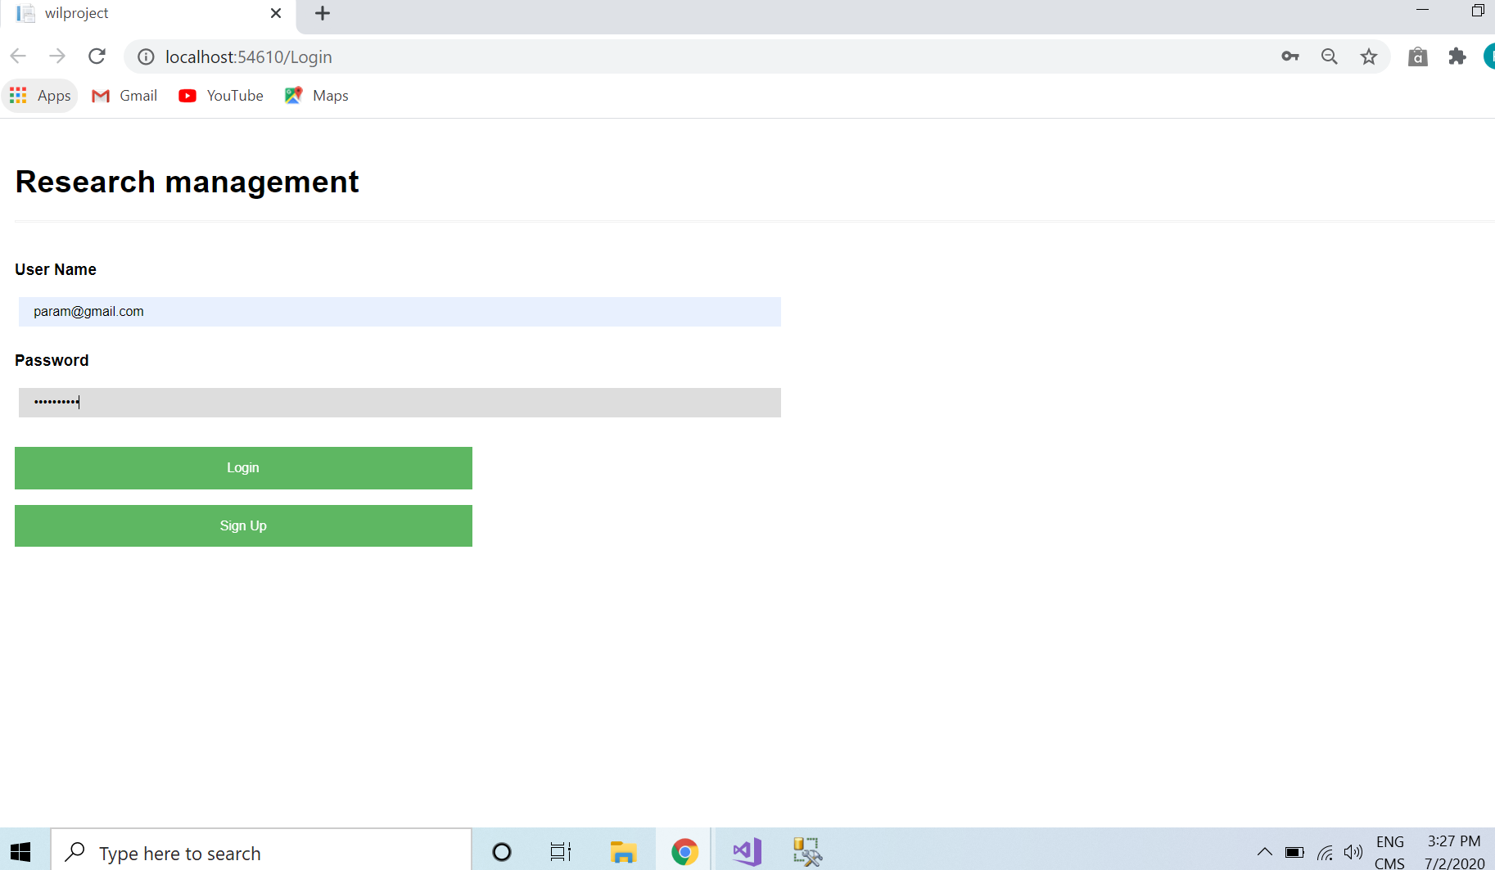

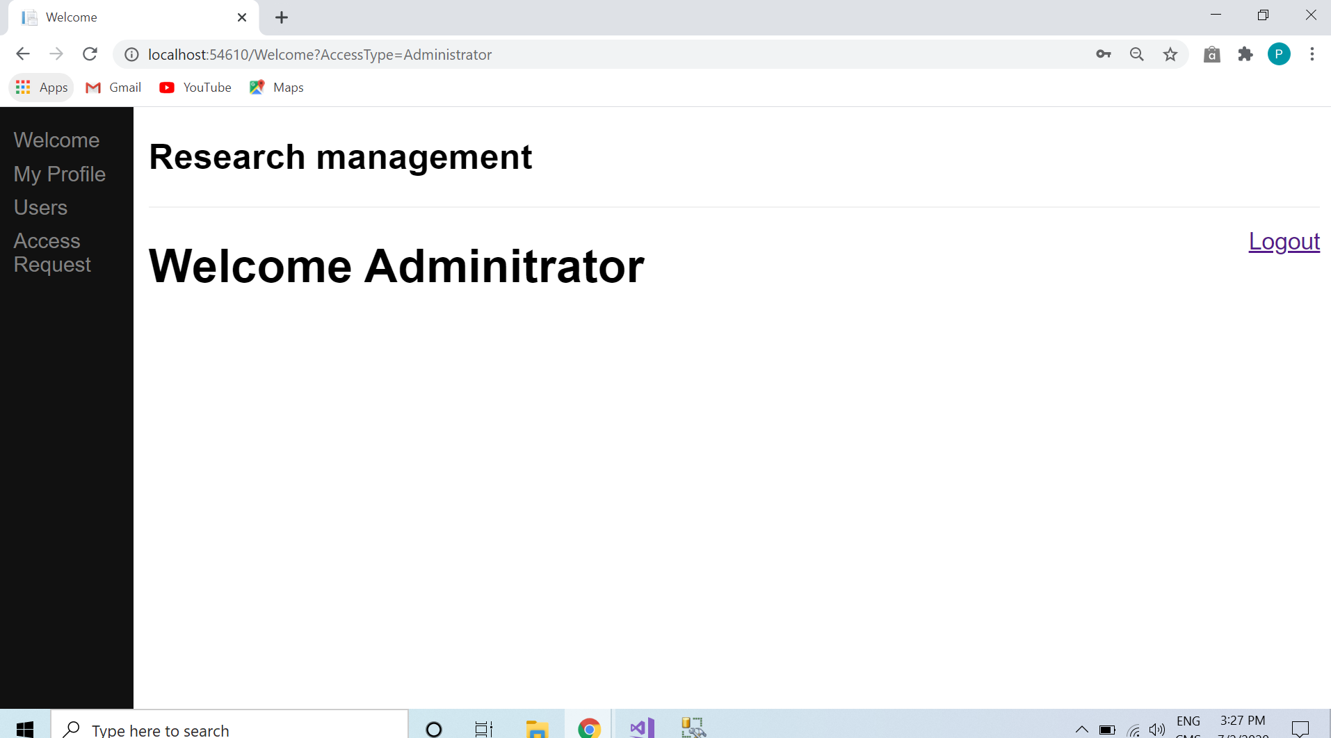

* **Logout:**

The logout button brings back the users to login page.

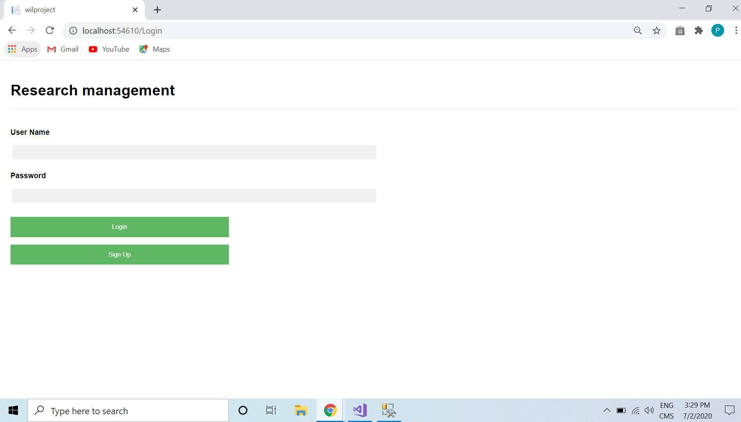

**1.2 Database:**

All the data and information stored in the database that users enter during the signup time. So here in this screenshot we enter the last row data at the time of signup and it stored on the database.

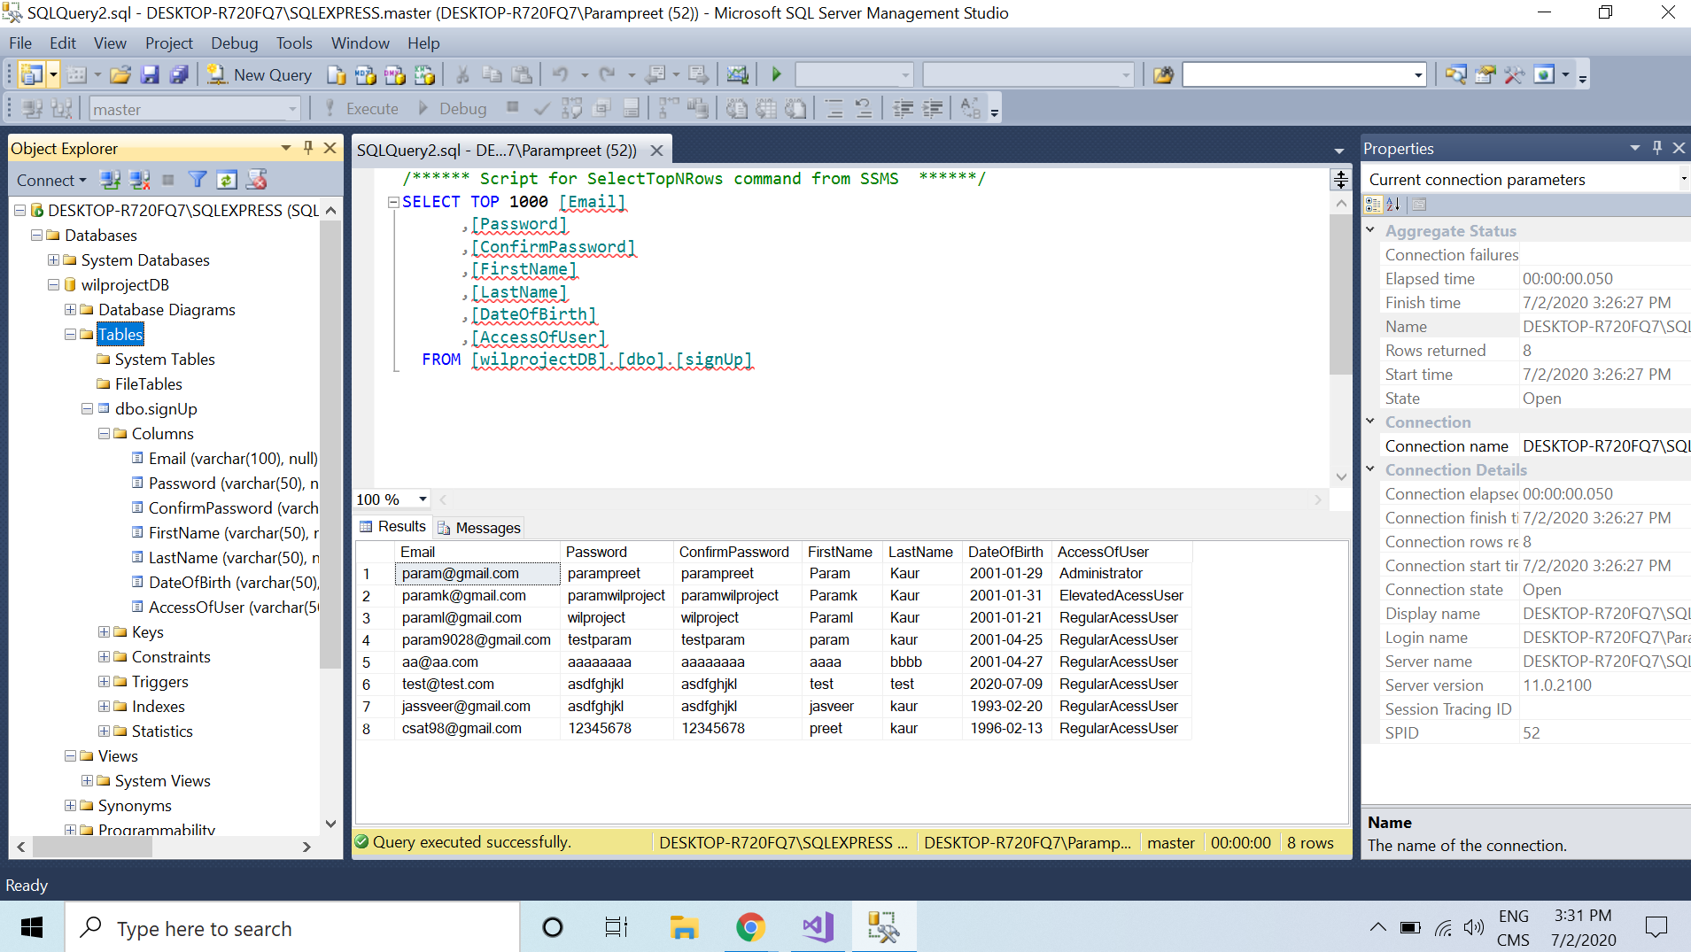

**1.3 References:**

<https://www.w3schools.com/asp/webpages_database.asp>

<https://www.youtube.com/watch?v=yBsl84hDtUg>

**Week 8**

**INDEX**

**1. Introduction**

**Screenshot of pages 1.1**

**Screenshot of database 1.2**

**Reference 1.3**

**1.1Screenshots of the functionalities of Add User and Edit User:**

* **Screenshot of welcome page:** where admin can see add user and edit user options with their user Id.

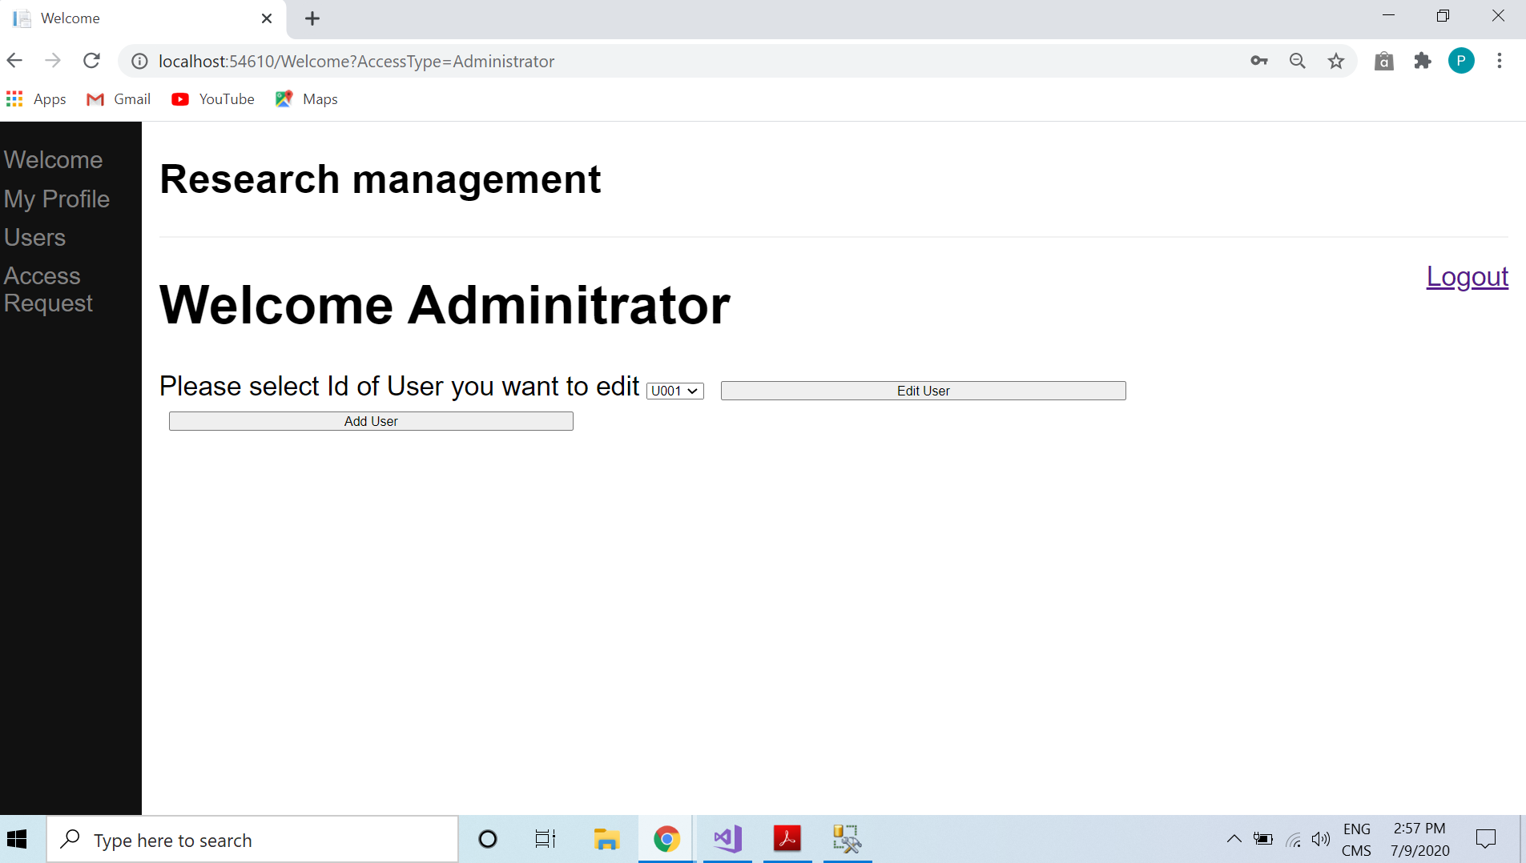

* **Add User:** after click on the add user button page will open that look like below screenshot.

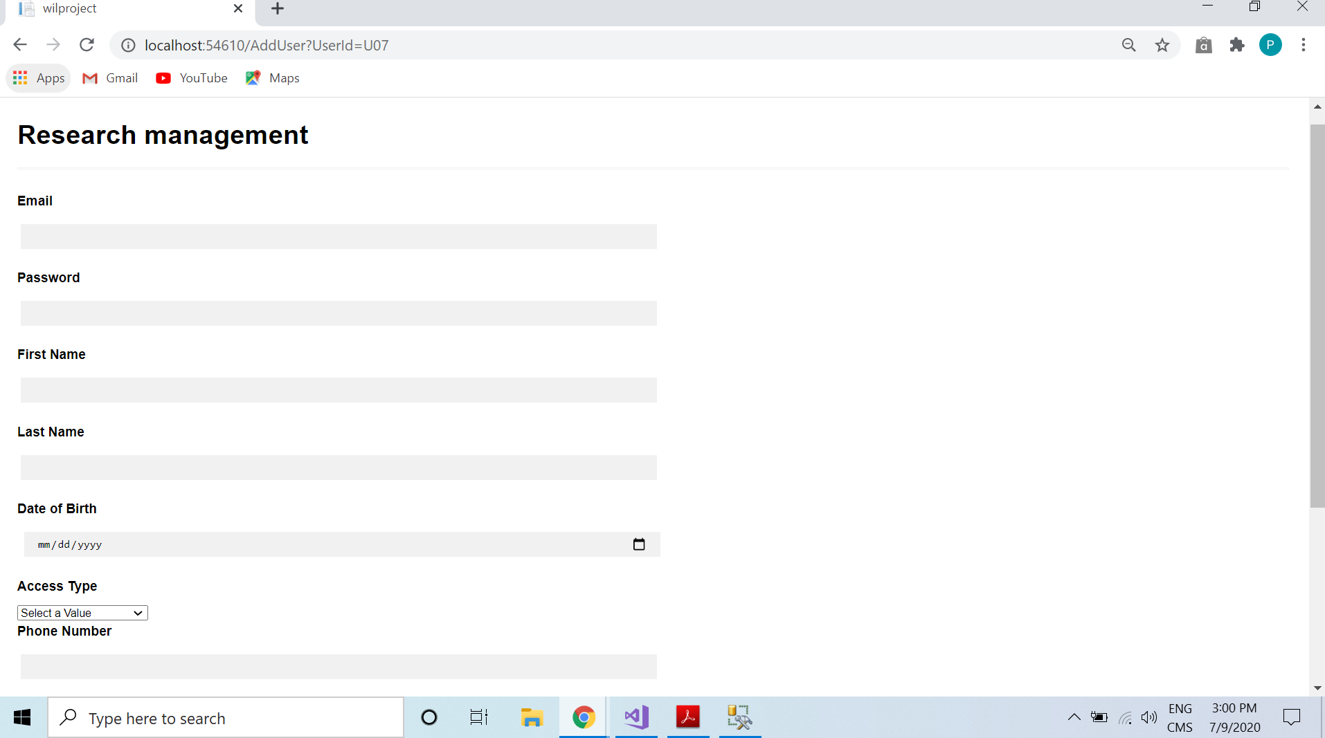

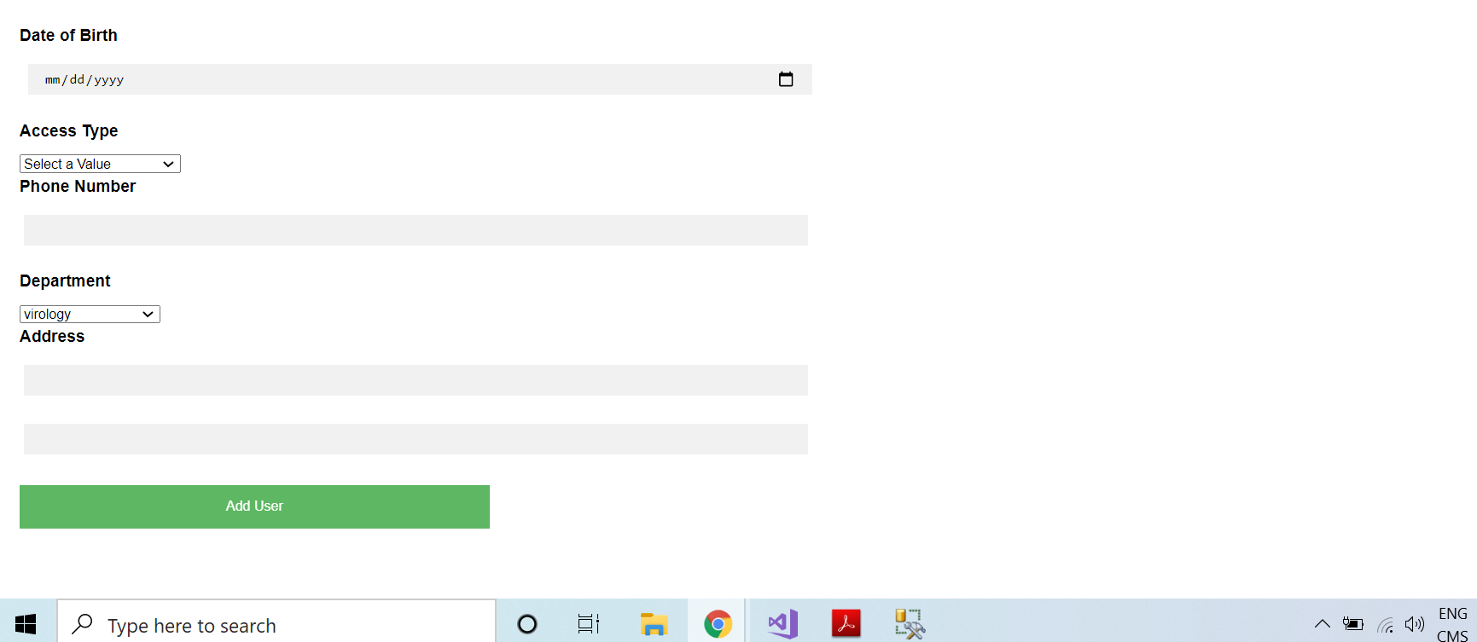

**Following user add in the database before adding new user:**

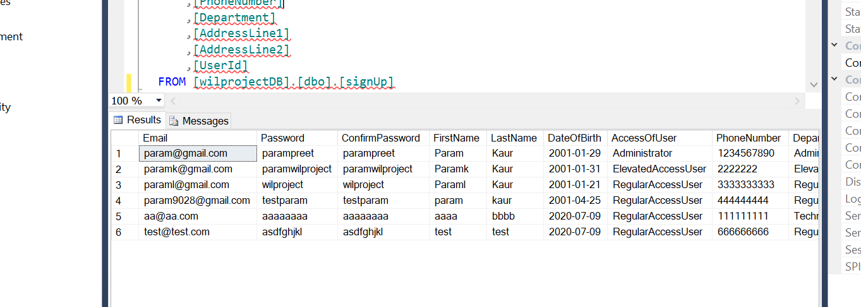

* **Admin add the user:**

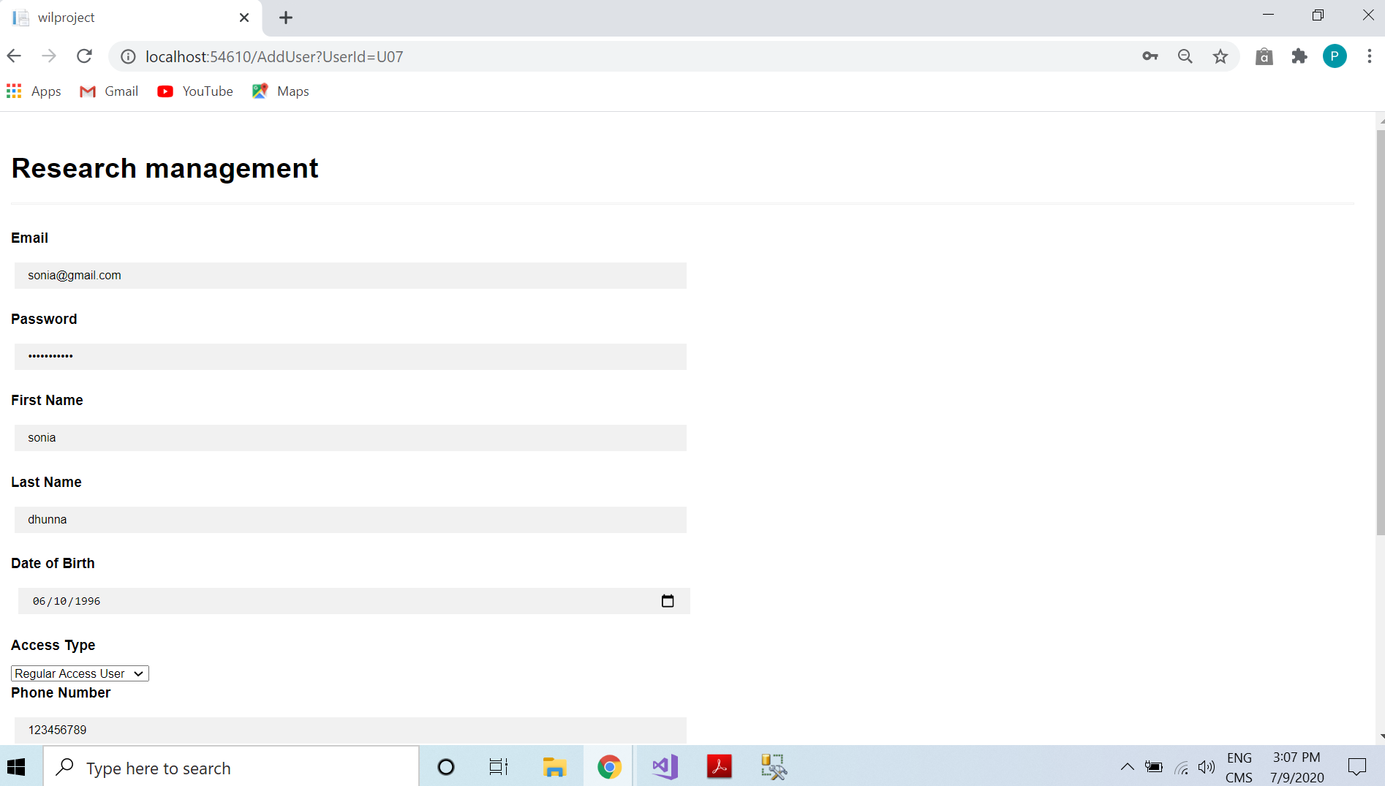

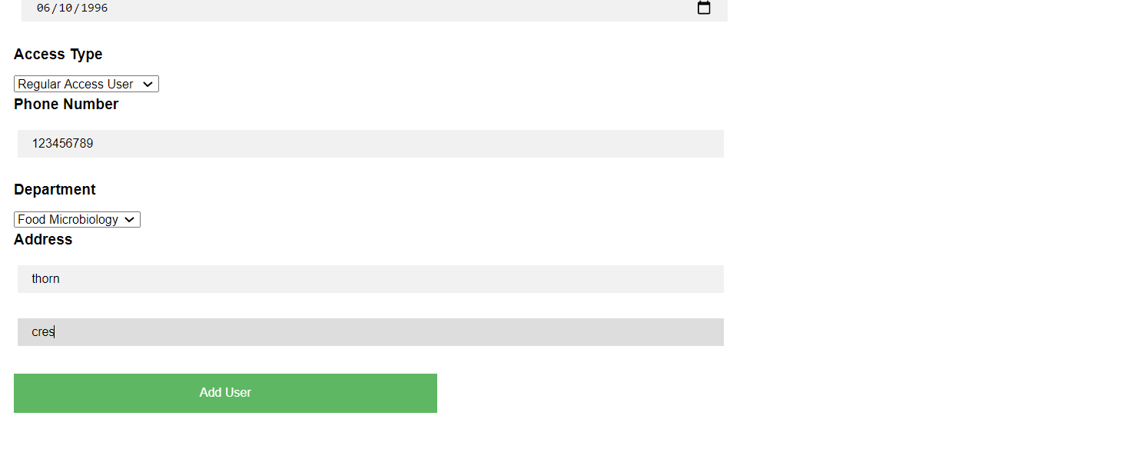

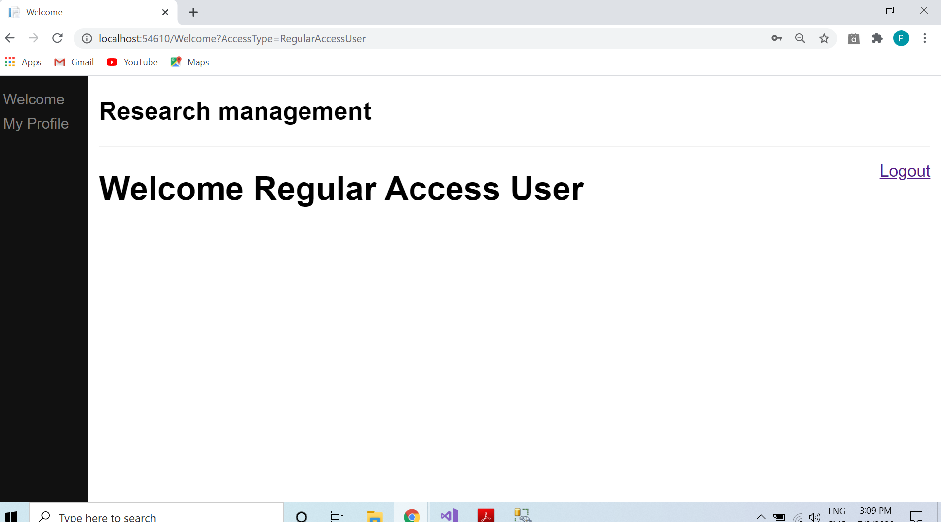

* **Data stored in the database:**

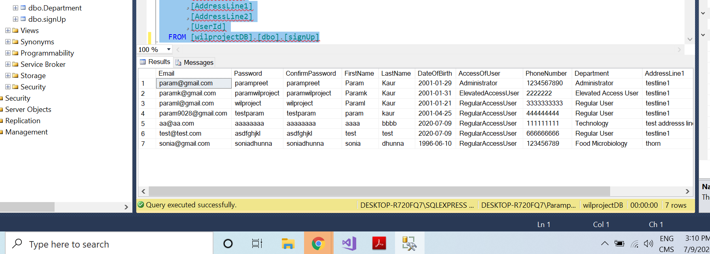

* **Edit user:** admin need to select the user id which he wants to change after select id click on edit button. All information came about that person as follow:

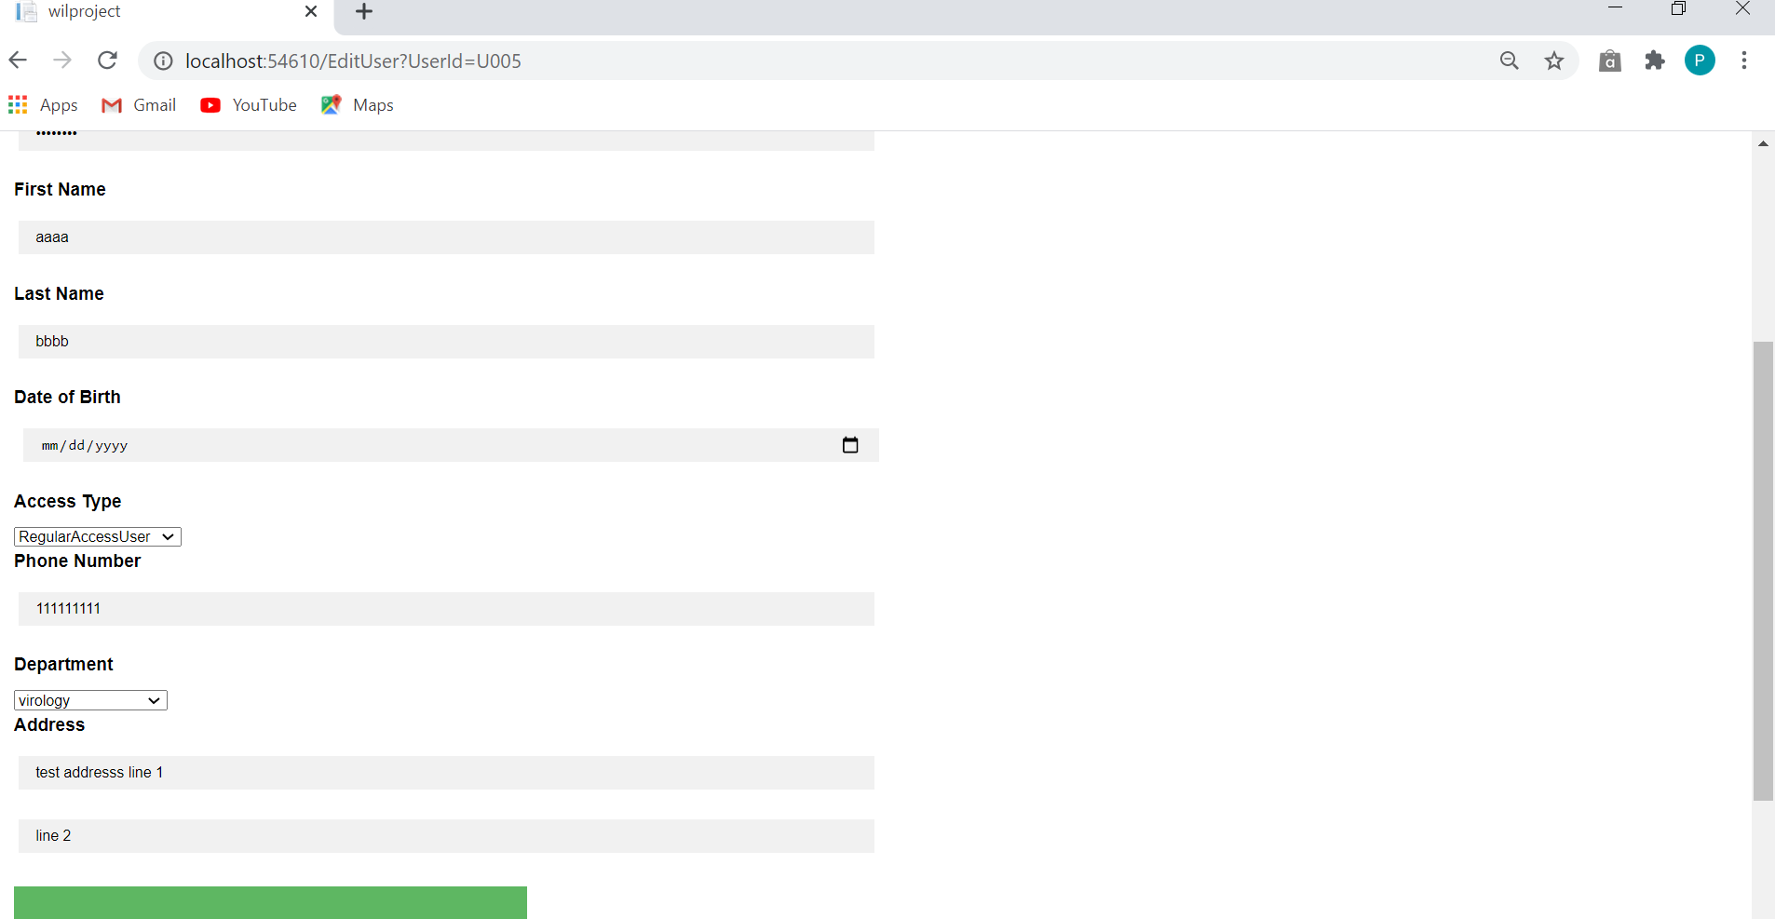

In this we going to change department of this user. Here its department is virology we going to change it with wireless network.

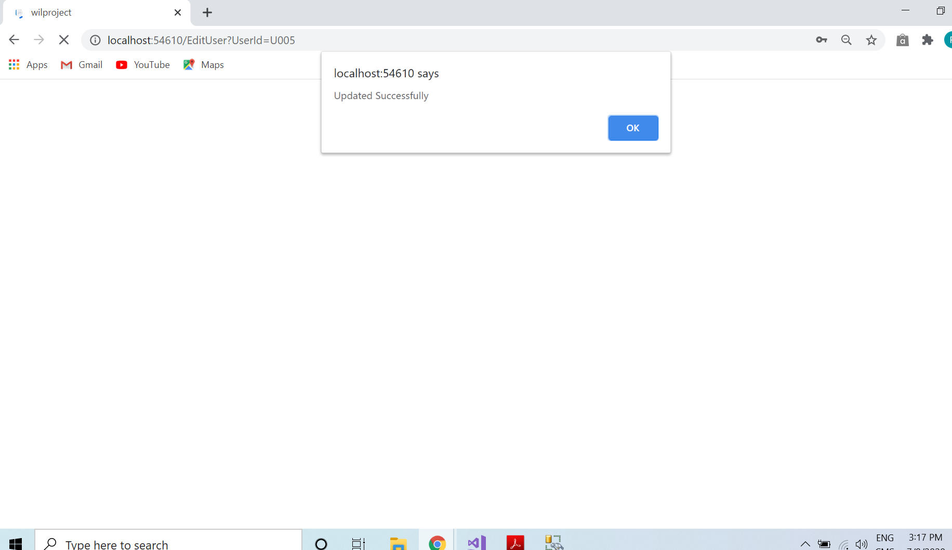

**In the database:**

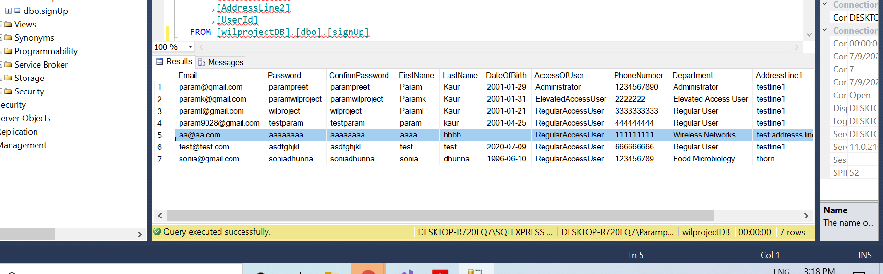

**1.2 Database**

* Department function:

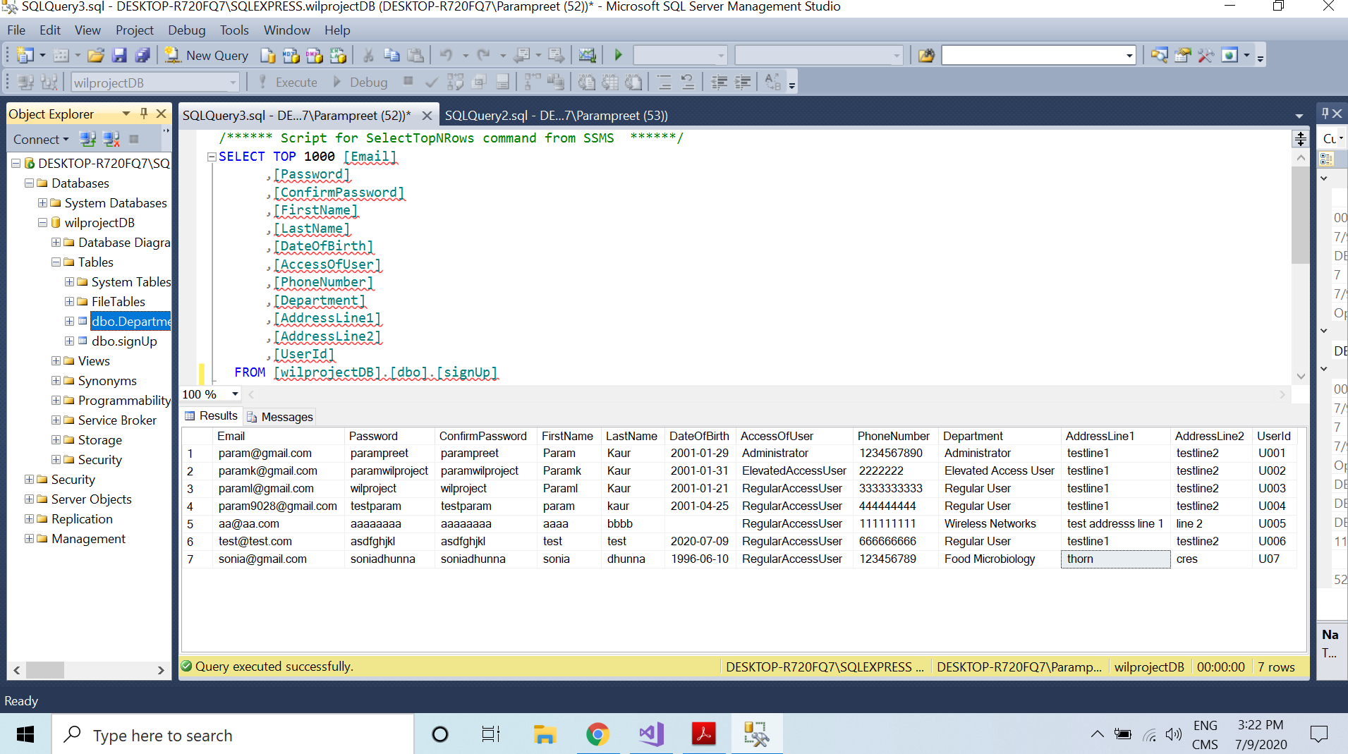

Binding: Add user

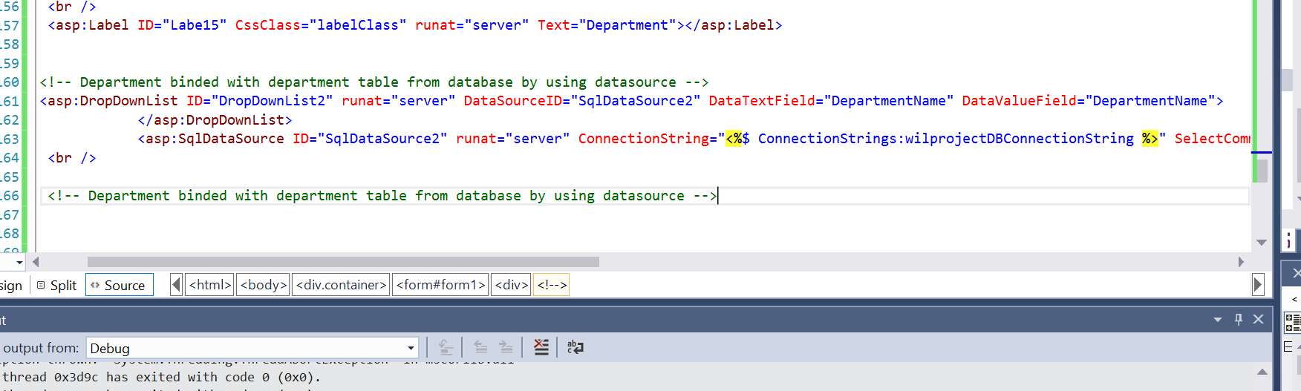

**Edit user Binding:**

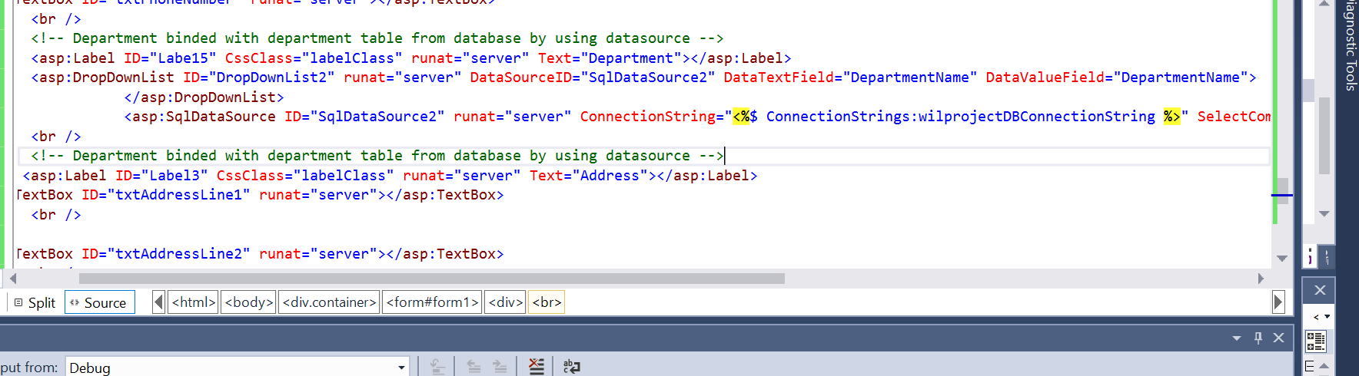

* **GitHub Screenshoot:**